#### 3.3.2. Notification (User)

-This feature support user to view list notification and allow user to view detail notification if they click on that notification.

- Functions are used in this feature:

+ View list notification

+ View detail notification

+ Mark all as read

***3.3.2.1. Function View list notification***

Step 1: Access the application

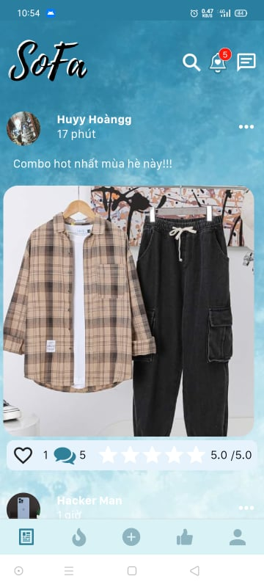

Step 2: On newsfeed click on icon “Notification”

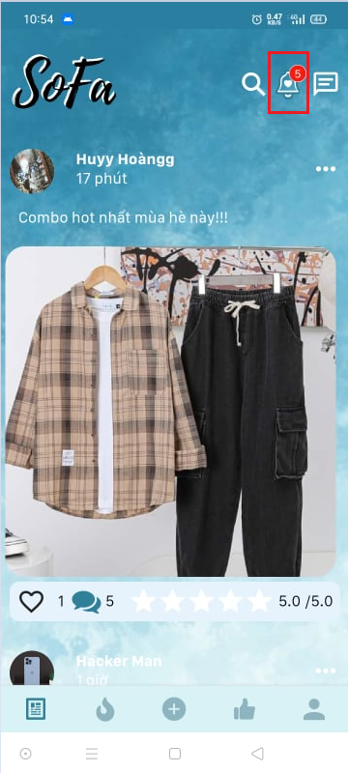

Step 3: View the list notification

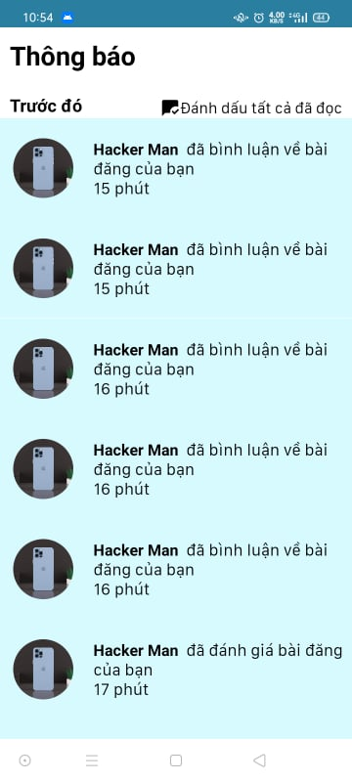

***3.3.2.2. Function View notification detail***

Step 1: On Notification screen, click on one notification on the list

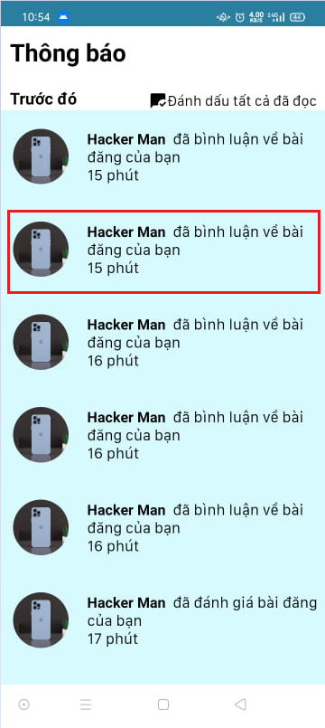

Step 2: View the post detail which send notification to user

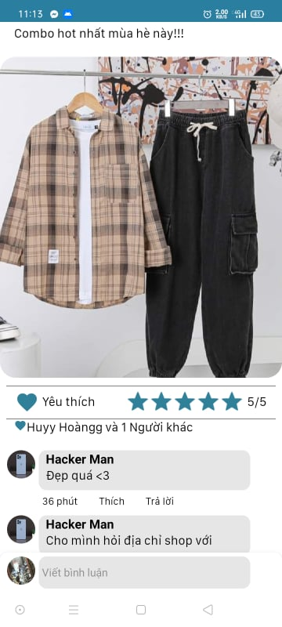

***3.3.2.3. Function Mark all notification as read***

Step 1: On Notification screen, click on “Đánh dấu tất cả đã đọc”

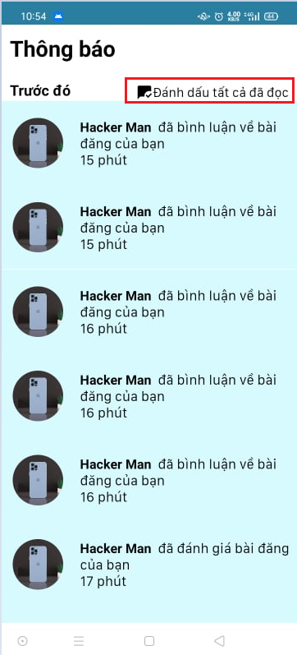

Step 2: View the list notification that all notifications are mark as read

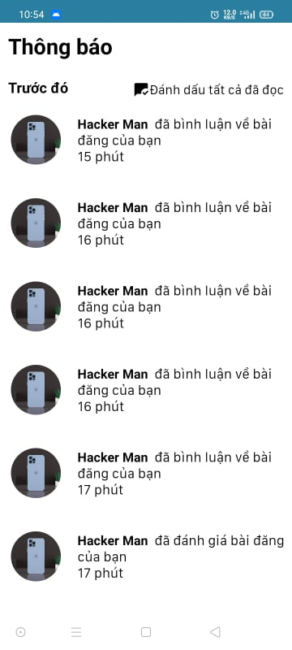

#### 3.3.2. Body measurement (User)

-This feature support user to view list body measurement and manage its

- Functions are used in this feature:

+ View list body measurement

+ View detail body measurement

+ Delete body measurement

***3.3.2.1. Function View list body measurement***

Step 1: Access the application



Step 2: On the newsfeed screen, click on “Account”

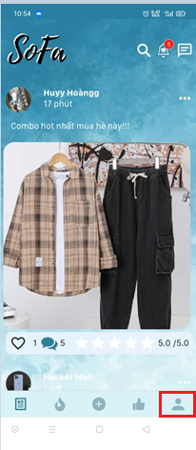

Step 3: On the “account” screen, click on “Chỉ số cá nhân”

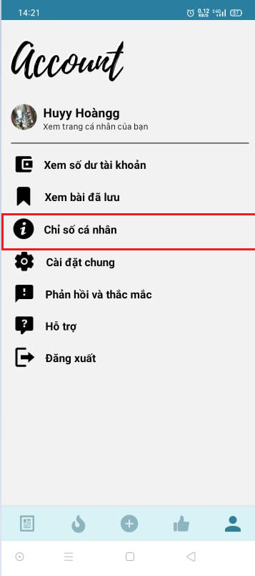

Step 4: View list body measurement

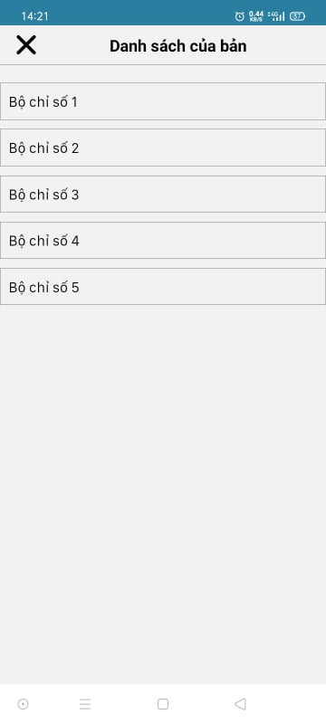

***3.3.2.2. Function View detail body measurement***

Step 1: On the list “Chỉ số cá nhân” screen, click on “Bộ chỉ số 1”

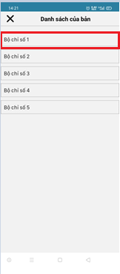

Step 2: View detail of body measurement name “Bộ chỉ số 1”

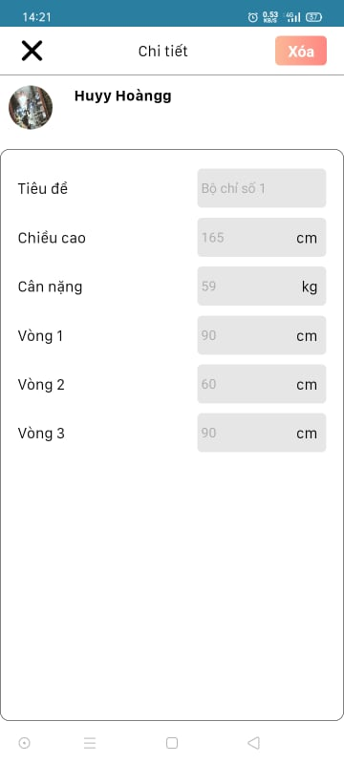

***3.3.2.3. Function Delete body measurement***

Step 1: On detail of body measurement name “Bộ chỉ số 1” screen, click on button “Xóa”

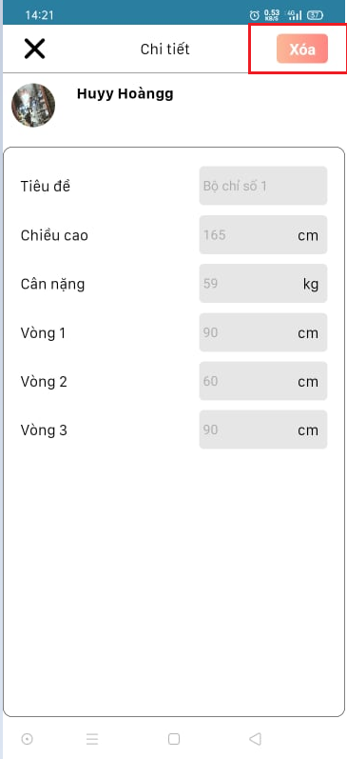

Step 2: Back to the body measurement list to view “Bộ chỉ số 1” is deleted

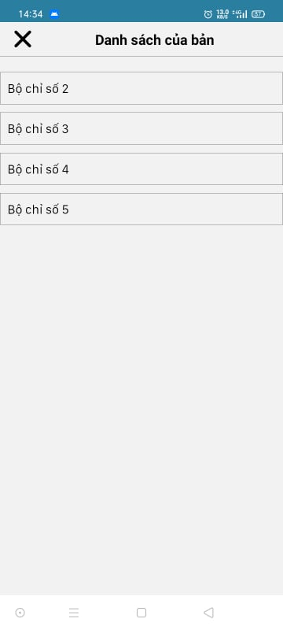

#### 3.3.2. Setting (User)

-This feature support user setting about account, notification and display

- Functions are used in this feature:

+ Change Password

+ Turn on/off notification

+ Change message theme

***3.3.2.1. Function Change Password***

Step 1: On the “account” screen, click on “Cài đặt chung”

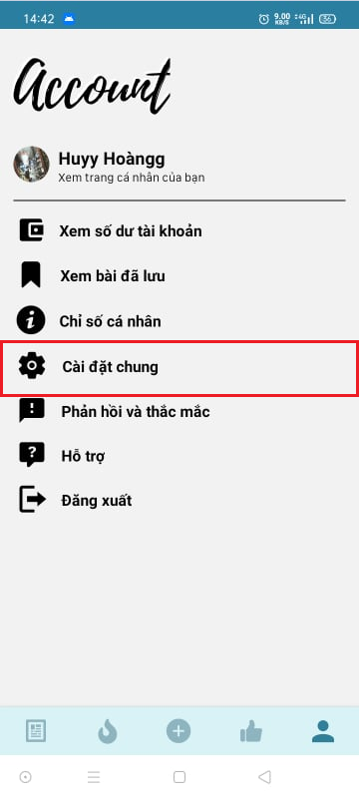

Step 2: On the “setting” screen, click on “Đổi mật khẩu”

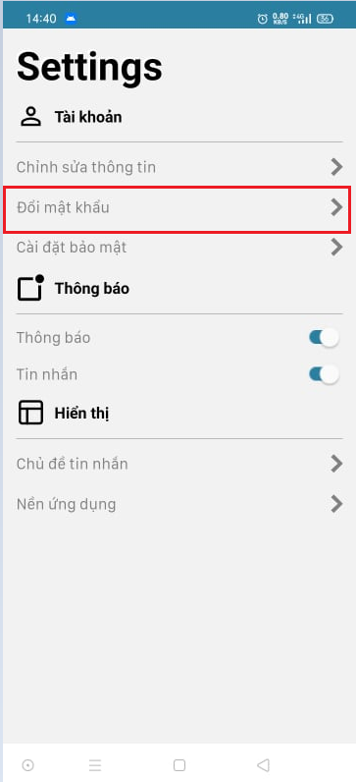

Step 3: On “Đổi mật khẩu” screen, input old password, new password, re-enter new password then click on “Xác nhận” then the password is changed

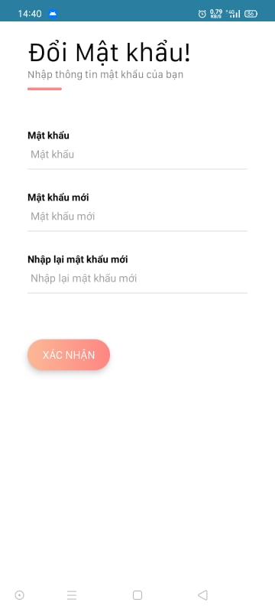

***3.3.2.2. Function Turn on/off notification***

Step 1: On “Settings” screen, swipe to right to turn on the notification and swipe to left to turn off notification

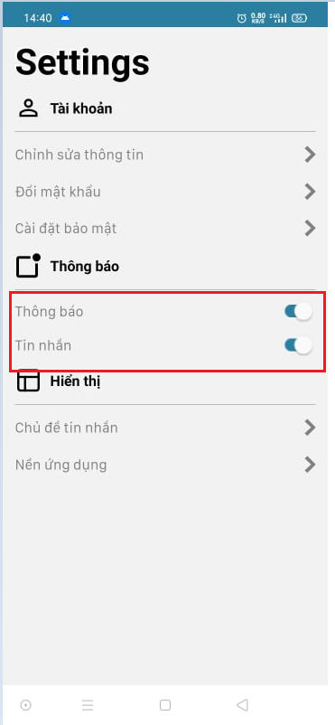

***3.3.2.3. Function Change message theme***

Step 1: On “Settings” screen, click on “Chủ đề tin nhắn”

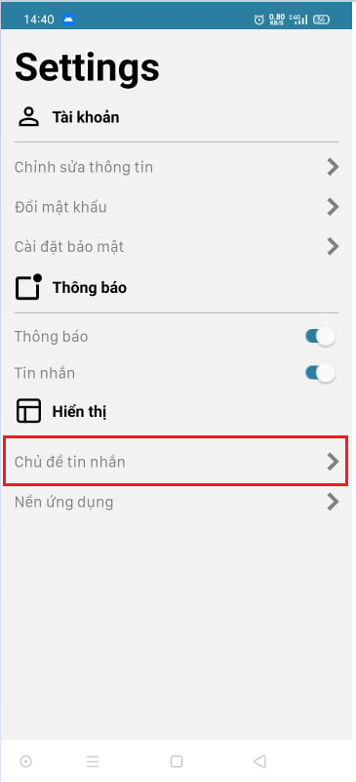

Step 2: On popup, choose the color which you want to change to

